EXPERIMENT 7
INTEGRATION OF ADVANCED ANALYTICS WITH BI REPORTS USING MICROSOFT POWER BI

1. AIM OF THE EXPERIMENT
To synthesize enterprise transaction datasets into diagnostic and prescriptive business intelligence reports using Microsoft Power BI, identifying critical operational drivers, cross-regional disparities, segment profitability patterns, and formulating executive-level strategic interventions.
2. TECHNICAL & ANALYTICAL OBJECTIVES
- Perform a multi-dimensional diagnostic audit of existing reporting dashboards and high-level KPI cards.
- Investigate regional sales distributions to uncover territory concentration and revenue skews.
- Evaluate product category performance to isolate margin leakages versus high-profit catalysts.
- Analyze customer tier contributions across Consumer, Corporate, and Home Office portfolios.
- Chart multi-year longitudinal trends to identify compound trajectory and seasonal cycles.
- Construct an Evidence-Based SWOT Diagnostic Matrix correlating findings with quantitative benchmarks.
- Author a structured Executive Briefing and slide presentation to defend data-driven recommendations during viva/evaluation.
3. SOFTWARE ENVIRONMENT & DATASET SPECIFICATIONS
Component | Technical Specification
BI Platform | Microsoft Power BI Desktop (Version 2.x+) with Power Query Engine
Primary Dataset | Global Superstore Dataset.xlsx (51,290 Multidimensional Transaction Records)
DAX Measures Evaluated | Total Sales, Total Profit, Total Transactions (Orders), Gross Margin %
Documentation Tool | Microsoft Word & Microsoft PowerPoint (Executive Slide Deck)

4. THEORETICAL FOUNDATIONS & CORE DEFINITIONS (VIVA PREPARATION)
• Descriptive vs. Diagnostic Analytics: While descriptive analytics details retrospective metrics ('What happened?'), diagnostic analytics dissects dependencies, correlations, and anomalies to explain root causes ('Why did it happen?').
• Key Performance Indicator (KPI) Variance: The mathematical ratio evaluating realized enterprise achievements against pre-set strategic quotas, expressed as: (Actual Metric / Target Metric) * 100.
• Data-Driven Decision Making (DDDM): The operational paradigm of basing organizational investments, inventory decisions, and price restructuring strictly on verified dashboard metrics rather than intuitive conjectures.
• Pareto Contribution & Cohort Concentration: The diagnostic principle identifying whether the majority of operating returns or friction points originate from a concentrated cluster of regions or customer categories.
5. STRUCTURED IMPLEMENTATION PROTOCOL
Phase 1: Workspace Initialization & Baseline Metric Audit
1.1. Launch Microsoft Power BI Desktop and retrieve the consolidated enterprise file (.pbix) containing completed models from previous practical stages.
1.2. Validate data model relationships and refresh global KPI cards: verify Total Orders (25.7K / 26K), Net Profit ($1.47M), Gross Turnover ($12.64M), and Baseline Margin (~11.6% - 12%).
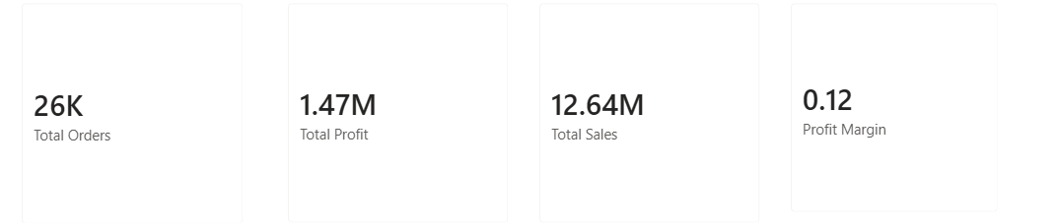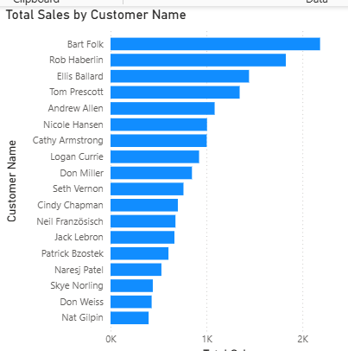

Phase 2: Granular Multi-Dimensional Diagnostics
2.1. Geographic Ranking: Interrogate regional sales bar visuals. Document leading hubs (Western Europe > $1.7M, Central America > $1.2M) and identify peripheral low-yield territories (Northern Europe, Eastern US, Central Asia) to quantify regional exposure.
2.2. Category Profit Margin Correlation: Dissect category metrics across Technology, Furniture, and Office Supplies. Contrast high gross sales against net operational profit yields to uncover hidden operational drag.
2.3. Customer Tier Breakdown: Segment consumer groupings across Consumer (51.06%), Corporate (30.07%), and Home Office (18.88%) to determine dependency risks.
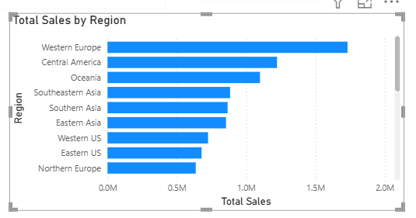

Phase 3: Longitudinal Trend & Velocity Tracking
3.1. Evaluate the multi-year progression curve (2014 to 2017). Observe consistent upward momentum rising from ~2.3M to well over 4M annually.
3.2. Record specific quarters with surging growth along with seasonal dips to formulate demand forecasting hypotheses.
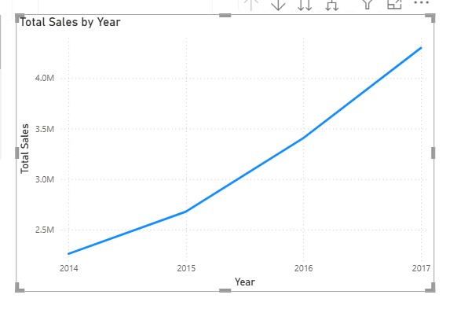

Phase 4: Evidence-Based SWOT Diagnostic Matrix
4.1. Core Strengths: Strong margin velocity in Technology ($4.7M+ sales, $663K profit at ~14.1% margin) and overachieved overall transaction targets (102.91%).
4.2. Critical Vulnerabilities: Significant margin compression in Furniture (yielding only ~$285K profit on $4.1M+ sales due to unchecked promotional markdowns).
4.3. Strategic Opportunities: Rationalize territory freight in lagging zones, eliminate unprofitable product discounting, and scale Corporate retention programs.
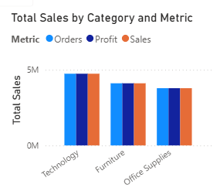

Phase 5: Executive Synthesis & Viva Presentation Deliverables
5.1. Draft the Diagnostic Business Insight Document comprising: Objective, Dataset Details, Empirical Findings, SWOT Matrix, Strategic Interventions, and Governance Conclusion.
5.2. Assemble an Executive Slide Deck (5 to 7 slides) summarizing: Executive Scorecard, Visual Diagnostics, Root-Cause Bottlenecks, and Actionable ROI Recommendations.
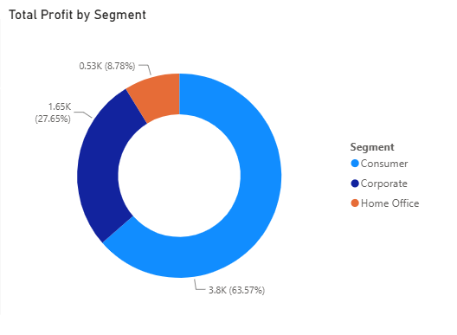

6. CONSOLIDATED DIAGNOSTIC OBSERVATIONS TABLE
Dimension / KPI | Empirical Value / Share | Benchmark Status | Strategic Implication
Gross Revenue | $12.64M | 97.25% of Quota ($13.0M) | Slight volume deficit; requires targeted regional acceleration.
Net Profit | $1.47M | 97.83% of Quota ($1.5M) | Disproportionately burdened by high furniture discounting.
Total Orders | 25,728 Transactions | 102.91% (Exceeded) | Strong transactional volume; high customer acquisition rate.
Top Region | Western Europe ($1.73M+) | Core Revenue Driver | Primary profit anchor; sustain key account relationships.
Lagging Category | Furniture (~7% Margin) | Severe Margin Drag | Requires restructuring of discount limits and shipping allowances.

7. EXECUTIVE RECOMMENDATIONS & INTERVENTION ROADMAP
• Pricing & Markdown Controls on Furniture: Institute a DAX-enforced dynamic discounting limit to ensure transactions maintain at least a 12% contribution margin, eliminating unhedged volume sales that erode profit.
• Territory Rebalancing & Logistics Optimization: Rationalize supply chains in peripheral markets (e.g., Central Asia, Eastern US) to reduce fulfillment friction while doubling down on dominant Western European distribution hubs.
• Expansion of High-Margin Enterprise Accounts: Capitalize on high-margin Technology hardware and Corporate clients by designing dedicated volume rebate programs rather than upfront discounts.
8. EXPERIMENT CONCLUSION & RESULT
Advanced diagnostic analytics techniques were successfully coupled with business intelligence models in Microsoft Power BI. The investigation accurately quantified organizational strengths, isolated category-level margin leakages, identified customer dependency risks, and validated data-driven recommendations presented through a standardized executive deliverable format.
9. ACADEMIC & INDUSTRY REFERENCES
- Sharda, R., Delen, D., & Turban, E. Business Intelligence, Analytics, and Data Science: A Managerial Perspective. Pearson.
- Ferrari, A., & Russo, M. The Definitive Guide to DAX: Business Intelligence with Microsoft Power BI and SQL Server Analysis Services.
- Kimball, R., & Ross, M. The Data Warehouse Toolkit: The Definitive Guide to Dimensional Modeling. Wiley.
- Microsoft Power BI Official Documentation: Advanced Diagnostic Analytics and Scorecard Tracking.

